Geospatial Data Infrastructure for Urban AI: A PostGIS-Based Exploratory Study of Shanghai Metro Deformation and Population Exposure

Changhyun Leeª, Kiyun Yu^{b}*
ª Seoul National University, Department of Civil, Urban, and Environmental Engineering, Seoul
^{b} Institute of Engineering Research, Seoul National University, Seoul
* Corresponding author: kiyun@snu.ac.kr

ABSTRACT:
Urban land subsidence assessment can benefit from considering physical deformation alongside residential population, but these data are often supplied as separate raster and vector datasets. This study developed a Python–PostGIS workflow integrating OpenStreetMap metro station locations, COMET-LiCSAR line-of-sight (LOS) deformation velocity and WorldPop 2020 residential population estimates at 100 m resolution for Shanghai. Of 769 initial records, 494 station locations were retained after cleaning. The integrated records were used to compare rankings based on absolute LOS velocity and an exposure-weighted priority score. Higher absolute LOS values appeared mainly at eastern, coastal and peripheral stations, whereas exposure-weighted priorities concentrated in central Shanghai. The latter ranking was strongly influenced by population because LOS values varied within a narrow range and is interpreted as exploratory. The resulting database provides a queryable geospatial data foundation that could support subsequent urban analysis and AI model development.
Keywords: Geospatial Database, Land Subsidence, Shanghai Metro, Smart City Resilience, Spatial ETL

Introduction
Metro systems are essential urban infrastructure, and monitoring surface deformation and land subsidence is relevant to their maintenance and safety. In Shanghai, soft ground conditions, groundwater changes and extensive construction activities have motivated studies using satellite-based InSAR to monitor ground deformation around the metro network (Chai et al., 2024).
Zhang et al. (2023) used time-series InSAR to analyse land subsidence along the Shanghai Metro and describe its spatial distribution. Building on this work, the present study asks how station rankings based on physical deformation change when residential population is incorporated as a proxy for exposure. Exploring this question requires linking deformation observations, metro station locations and population estimates.
To support this comparison, a Python-based extract, transform and load (ETL) workflow was used to integrate OpenStreetMap station data (OpenStreetMap contributors, n.d.), COMET-LiCSAR LOS deformation velocity (Lazecký et al., 2020) and WorldPop residential population estimates (WorldPop, 2025) into PostgreSQL/PostGIS. The study focuses on establishing a queryable station-level database and illustrating its use through an exploratory comparison of rankings. This data infrastructure could also provide a starting point for subsequent Urban AI applications.

Problems / Challenges
Previous research has addressed the integration of railway datasets from different sources and resolutions into a common spatial model (Corongiu et al., 2018). Research on urban digital twins has likewise highlighted the importance of considering data semantics, structure and storage when integrating heterogeneous sources (Jeddoub et al., 2023).
In the present study, LiCSAR deformation data, OpenStreetMap station locations and WorldPop population estimates were obtained separately and differ in their spatial representations, resolutions and attributes. Linking these sources requires explicit procedures for matching station locations to raster observations and handling incomplete or inconsistent records. A further challenge is to retain the interpretation of each variable when combining them: LOS deformation velocity and residential population describe different aspects of the station surroundings and have distinct limitations. The resulting structure needs to support consistent retrieval and comparison without obscuring these differences.

AI Methodology or Application
This study developed a geospatial data integration workflow to organise station-level records for urban analysis and potential AI applications. Python was used to clean and standardise metro station records, associate LiCSAR LOS deformation velocity and WorldPop population estimates with station locations, and load the integrated records into PostgreSQL/PostGIS. SQL queries were then used to retrieve and compare station-level information.
In the context of Urban AI, this workflow provides a common analytical structure in which deformation and population attributes can be accessed together for each station. The exposure-weighted score serves as a formula-based example of using these integrated records to explore station-level priorities. The comparison illustrates a potential use of the database and establishes a starting point for future research into AI model development and evaluation.

Case Study or Empirical Example
The Shanghai Metro network was examined as an empirical case. Previous studies have used time-series InSAR to monitor ground deformation along the network and have combined PS-InSAR with machine learning to assess subsidence risk (Zhang et al., 2023; Chai et al., 2024). The present case examines the same urban context from a complementary perspective by integrating physical deformation with station locations and population exposure.
The initial OpenStreetMap dataset contained 769 metro-related records. After removing records with missing essential information and resolving duplicated station names, 494 station locations were retained. Each station was linked to a COMET-LiCSAR LOS deformation value and the WorldPop residential population estimate of the corresponding 100 m grid cell. The resulting station-level dataset was stored in PostgreSQL/PostGIS and visualized in QGIS.
The physical deformation map was produced using the absolute LOS deformation velocity at each station. Relatively high values appeared mainly at eastern, coastal, and peripheral stations, including several locations identified in the source data as planned or under construction.
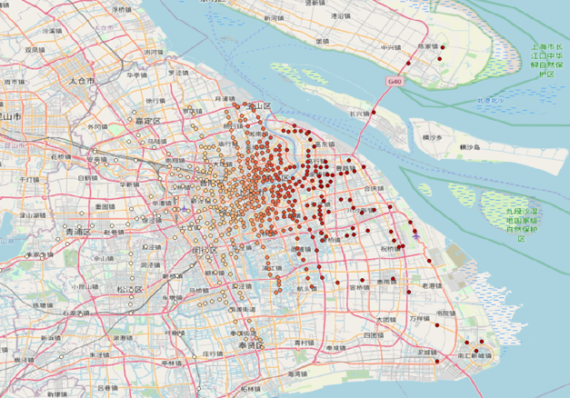
Figure 1. Spatial distribution of absolute LOS deformation velocity at Shanghai Metro stations. Darker red indicates a higher relative value. Map by the authors; basemap © OpenStreetMap contributors, ODbL.

Population exposure was then incorporated using an exposure-weighted priority score:

The resulting map showed a greater concentration of high-priority stations in central Shanghai, including Middle Huaihai Road, Lujiabang Road, Dapuqiao, Xinzha Road, and Xiaonanmen.
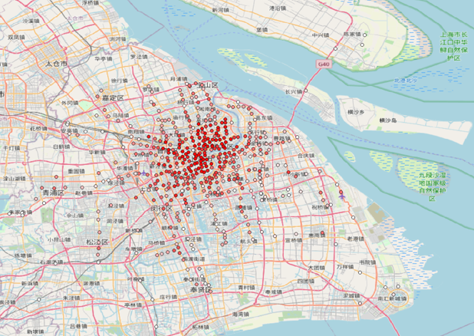
Figure 2. Exposure-weighted priority based on LOS deformation and residential population. Darker red indicates a higher relative score. Map by the authors; basemap © OpenStreetMap contributors, ODbL.

The comparison demonstrates that physical deformation and exposure-informed priority can produce different spatial patterns. Because the LOS values in the current dataset varied within a relatively narrow range, the integrated ranking was strongly influenced by population. The results should therefore be interpreted as an exploratory demonstration of heterogeneous data integration rather than as a validated prediction of subsidence risk.

DISCUSSION AND CONTRIBUTION TO THE FIELD
The main contribution is an integrated spatial database that links metro station locations with LOS deformation velocity and residential population estimates. The Shanghai case illustrates how the same station-level records can support two different analytical views: ranking stations by absolute LOS deformation velocity and ranking them using an exposure-weighted score. Their differing spatial patterns demonstrate the analytical value of bringing physical observations and population information into a common queryable structure. However, this comparison does not establish the accuracy of either ranking as a measure of infrastructure risk.
The relevance to Urban AI lies in the preparation and organisation of data that subsequent applications could consume. The database makes station-linked attributes available through SQL, providing a common point of access for further analysis and potential model development. This is a concrete contribution at the data infrastructure stage. Its value is demonstrated here through the retrieval and comparison of integrated records; improvements in AI performance, processing efficiency or operational decision outcomes have not been tested.
The interpretation of the integrated score requires a distinction between hazard, exposure, vulnerability and risk. LOS deformation velocity describes observed ground movement and provides information relevant to the physical hazard. The WorldPop estimate represents residential population in the grid cell containing each station and serves as a limited proxy for exposure. Neither variable directly measures infrastructure vulnerability or the likelihood and consequences of damage. The exposure-weighted score therefore expresses a relative ranking under the selected formula; it does not estimate failure probability, expected losses or overall infrastructure risk.
Data provenance is also important for interpreting and reusing the integrated records. Each station-level value should be traceable to its source dataset and version, observation or reference period, spatial reference system, extraction procedure and any treatment of missing values. Retaining this information would help users distinguish changes in the underlying observations from changes introduced by data processing or dataset updates. Further development should make these links explicit so that subsequent analyses can assess whether the combined records are suitable for their intended purpose.
Several limitations constrain the interpretation of the station rankings. First, LOS velocity measures movement along the satellite line of sight and cannot be interpreted directly as vertical subsidence. Using its absolute value also removes directional information. Second, population extracted from a single 100 m grid cell does not represent a station catchment, passenger volume or the number of people exposed to infrastructure failure. Third, the inclusion of planned or under-construction stations alongside operational stations limits the interpretation of the combined ranking for existing transport services.
The exposure-weighted ranking was strongly influenced by population because LOS values varied within a relatively narrow range. The logarithmic transformation reduces the numerical contrast between population values, but does not establish an empirically validated balance between deformation and exposure. The robustness of the ranking requires further assessment using alternative spatial aggregation methods and weighting choices, together with independent observations. Differences in the reference periods, spatial resolutions and uncertainties of the source datasets also need to be assessed before stronger conclusions can be drawn.
The database could support preliminary screening by allowing users to retrieve and compare station-level deformation and population information. Any use of these results to inform maintenance or planning would require additional evidence and review by relevant engineering professionals.

Conclusion
This study developed a PostGIS-based workflow for integrating Shanghai Metro station locations, LiCSAR LOS deformation velocity, and WorldPop residential population estimates. The comparison showed that stations with relatively high physical deformation were concentrated mainly in eastern, coastal, and outer areas, whereas exposure-weighted priorities shifted toward densely populated central Shanghai. This illustrates that physical deformation and population exposure can produce different spatial priorities for urban infrastructure management.
The principal contribution to Urban AI is a queryable geospatial data foundation that connects heterogeneous observations at the station level. The exposure-weighted score illustrates one use of this database and remains an exploratory indicator, particularly because population strongly influenced the ranking. Further work should document and validate the data integration procedures, assess alternative station catchment definitions, distinguish operational status and incorporate passenger flows or other relevant observations. These improvements would strengthen the basis for subsequent AI applications and urban infrastructure analysis.

ACKNOWLEDGEMENTS
This work was supported by the Korea Agency for Infrastructure Technology Advancement (KAIA) grant funded by the Ministry of Land, Infrastructure and Transport (Grant RS-2022-00143336).

references
Chai, L., Xie, X., Wang, C., Tang, G., & Song, Z. (2024). Ground subsidence risk assessment method using PS-InSAR and LightGBM: A case study of Shanghai metro network. International Journal of Digital Earth, 17(1), 2297842. https://doi.org/10.1080/17538947.2023.2297842
Lazecký, M., Spaans, K., González, P. J., Maghsoudi, Y., Morishita, Y., Albino, F., Elliott, J., Greenall, N., Hatton, E., Hooper, A., Juncu, D., McDougall, A., Walters, R. J., Watson, C. S., Weiss, J. R., & Wright, T. J. (2020). LiCSAR: An automatic InSAR tool for measuring and monitoring tectonic and volcanic activity. Remote Sensing, 12(15), 2430. https://doi.org/10.3390/rs12152430

OpenStreetMap contributors. (n.d.). OpenStreetMap [Data set]. https://www.openstreetmap.org
WorldPop. (2025). Global demographic data: Public release R2025A V1 [Data set documentation]. University of Southampton. https://hub.worldpop.org/
Zhang, J., Ke, C., Shen, X., Lin, J., & Wang, R. (2023). Monitoring land subsidence along the subways in Shanghai on the basis of time-series InSAR. Remote Sensing, 15(4), 908. https://doi.org/10.3390/rs15040908
Corongiu, M., Tucci, G., Santoro, E., & Kourounioti, O. (2018). Data integration of different domains in geo-information management: A railway infrastructure case study. The International Archives of the Photogrammetry, Remote Sensing and Spatial Information Sciences, XLII-4, 121–127. https://doi.org/10.5194/isprs-archives-XLII-4-121-2018
Jeddoub, I., Nys, G.-A., Hajji, R., & Billen, R. (2023). Digital twins for cities: Analyzing the gap between concepts and current implementations with a specific focus on data integration. International Journal of Applied Earth Observation and Geoinformation, 122, 103440. https://doi.org/10.1016/j.jag.2023.103440

